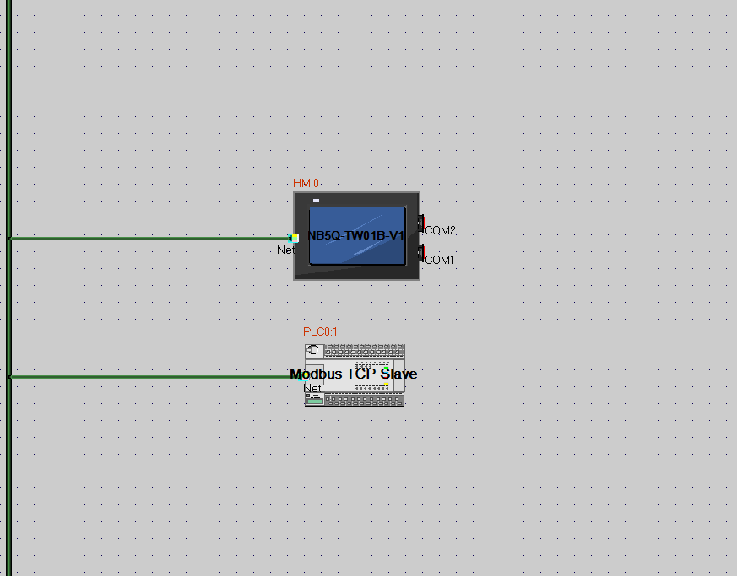
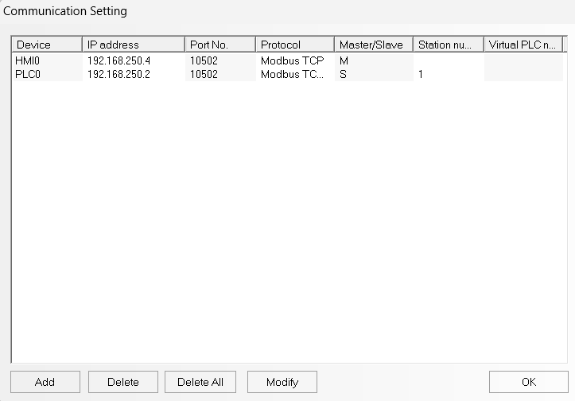
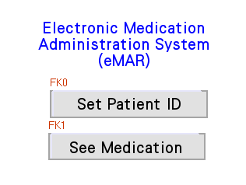
Components | Item on screen | Function
Text | Electric Medication Administration System (eMar) | -
Function key | Set Patient ID | Change screen to screen 10
 | See Medication | Change screen to screen 11

*Status 0 – button not pressed
*Status 1 – button pressed
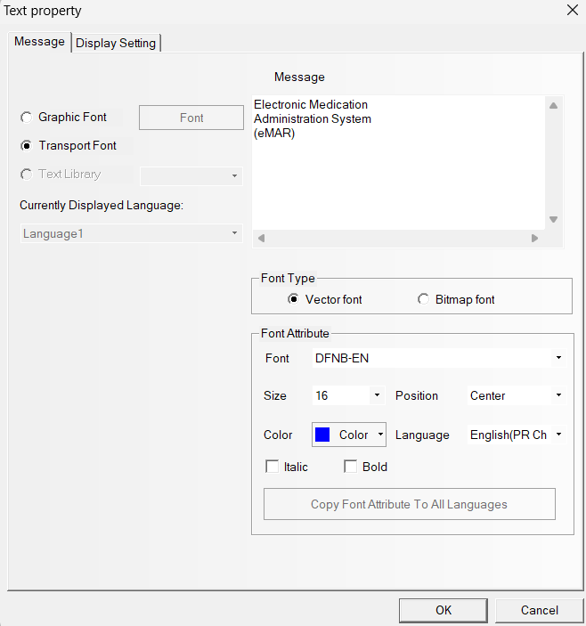
Figure 1: Text – message
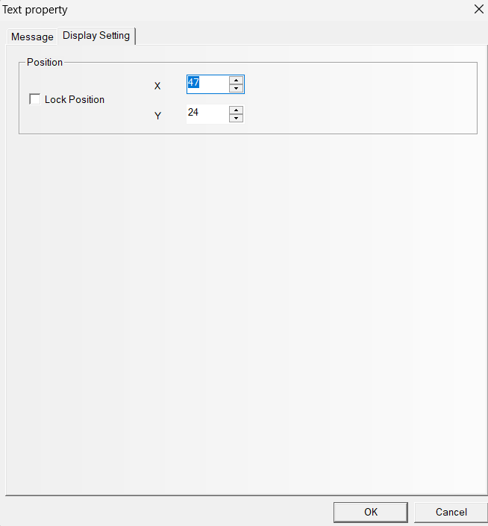
Figure 2: Text - display setting

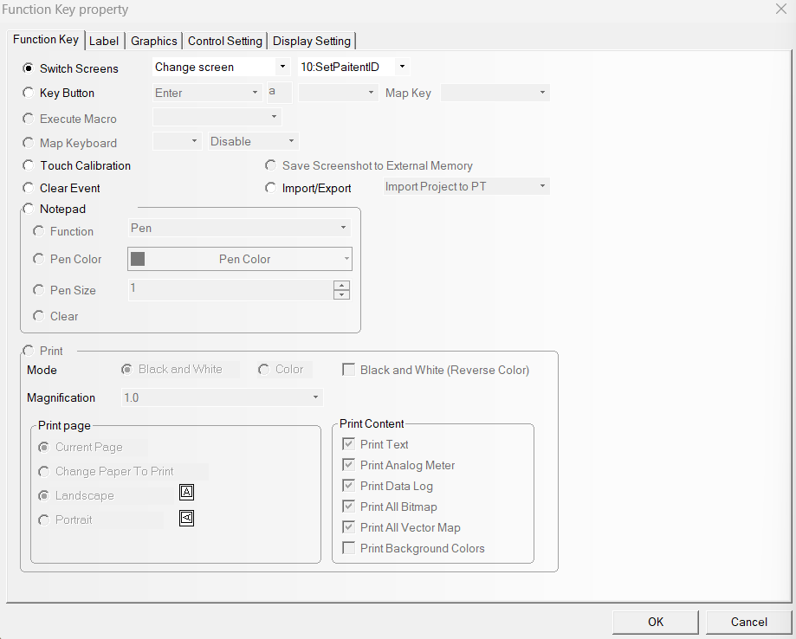
Figure 3: Function key
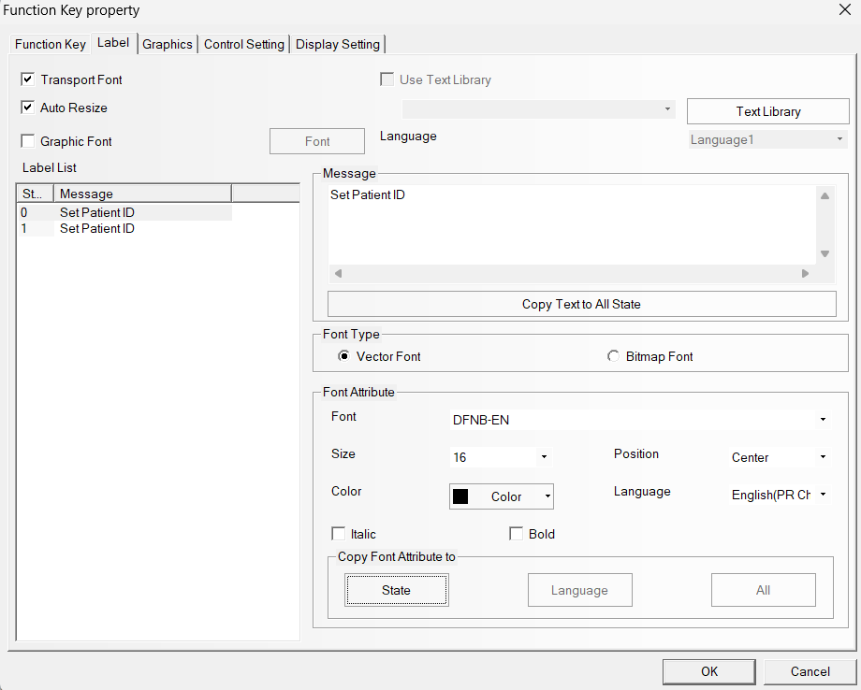
Figure 4: Function key -label
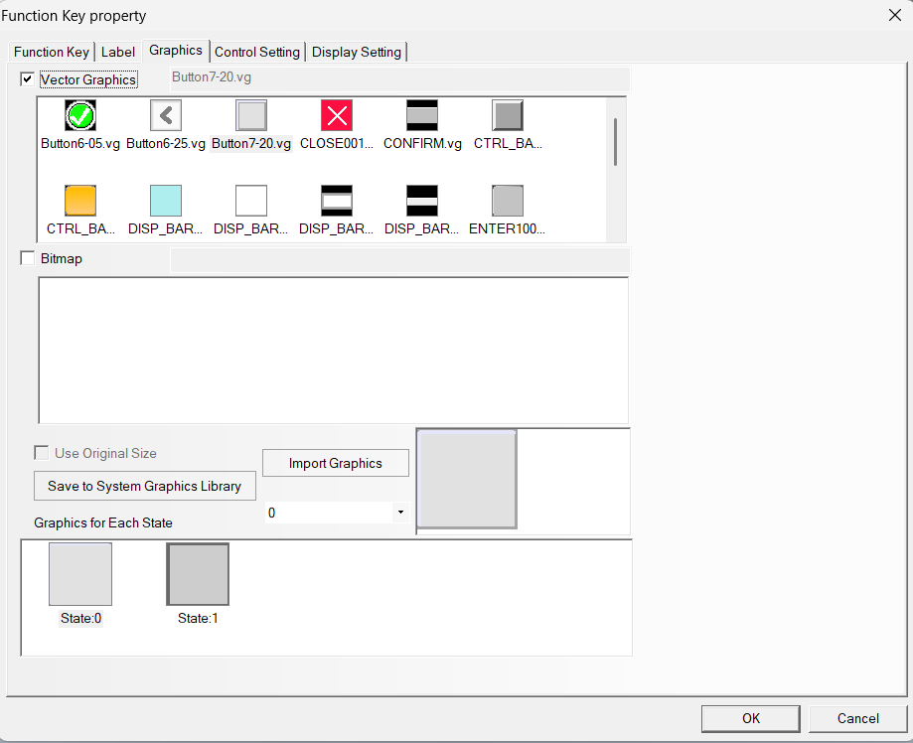
Figure 5: Function key -graphics

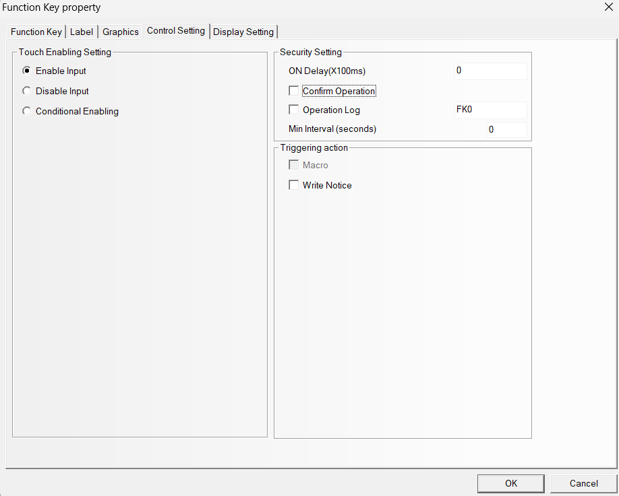
Figure 6: Function key - control setting (X)
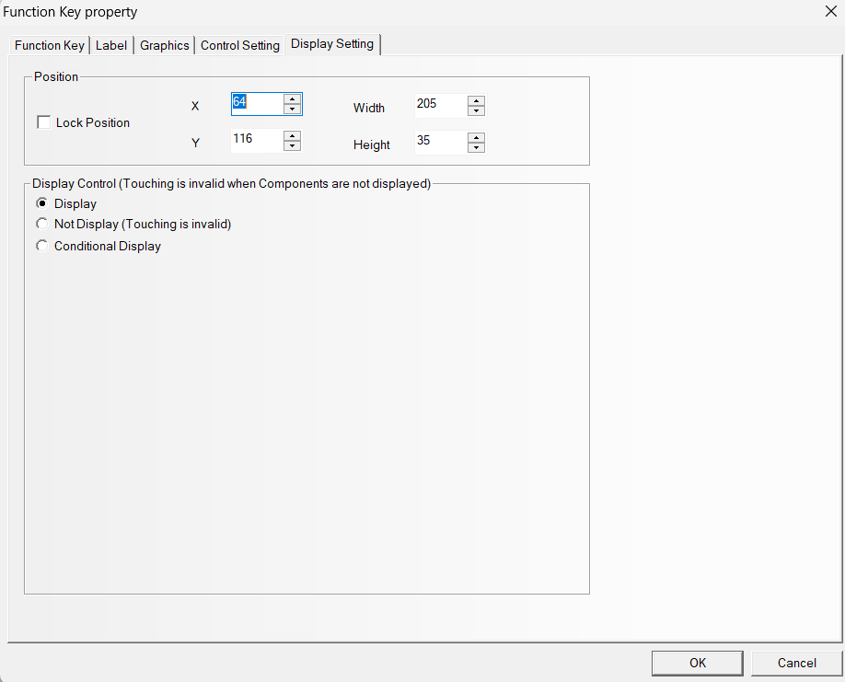
Figure 7: Function key- display setting

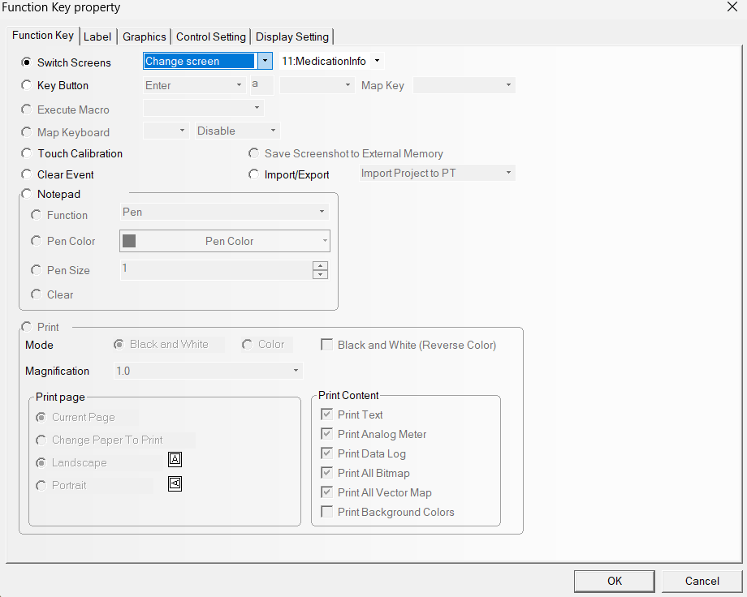
Figure 8: Function key (See medication)
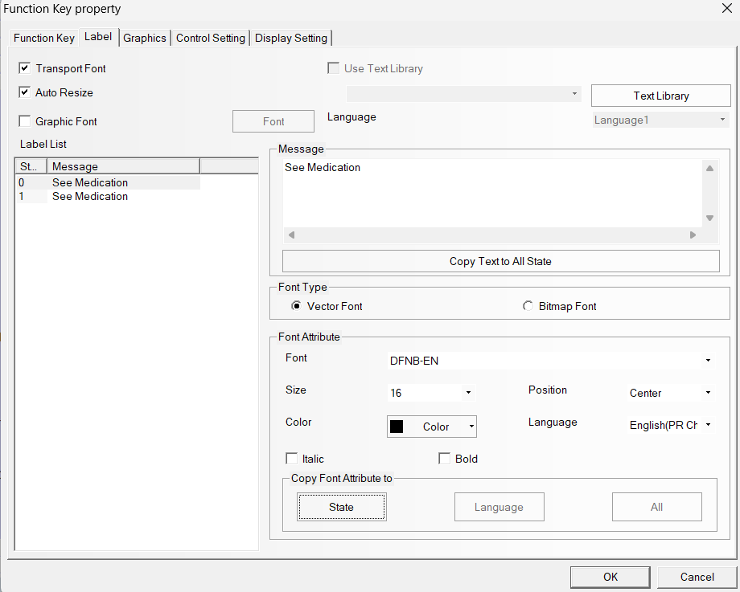
Figure 9: Function key (See medication) – label

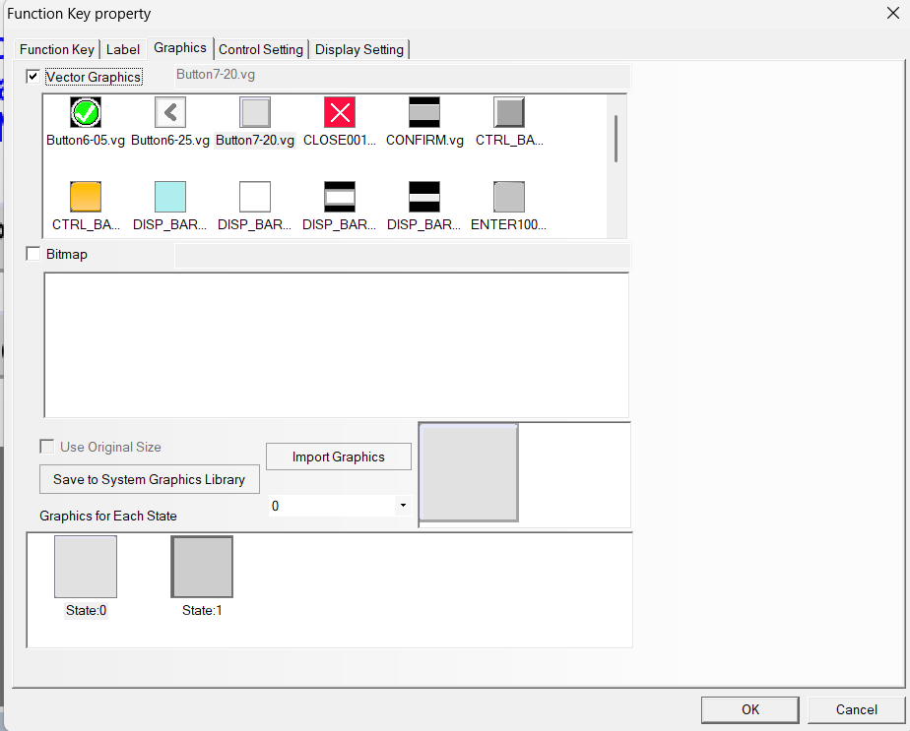
Figure 10: Function key (See medication) - graphics
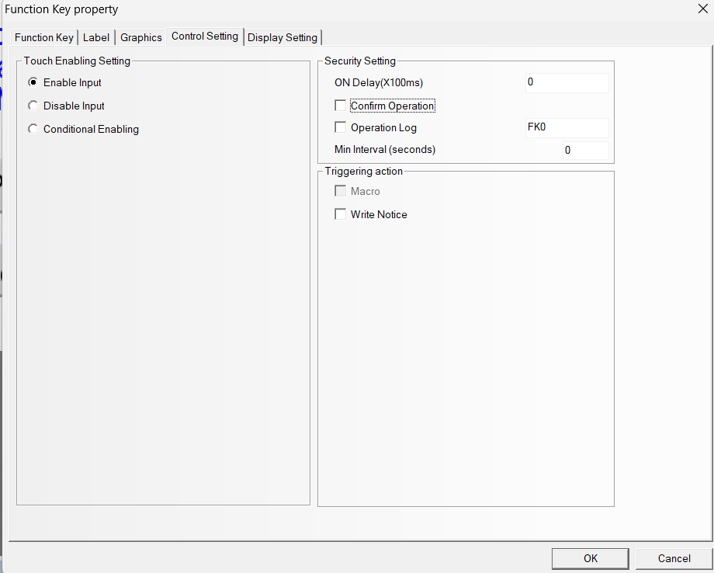
Figure 11: Function key (See medication) – control setting (X)

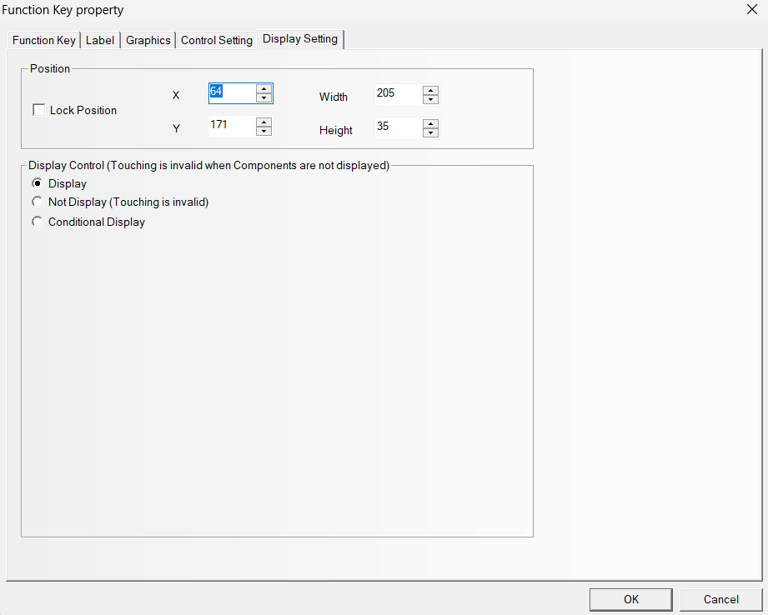
Figure 12: Function key (See medication) – display setting

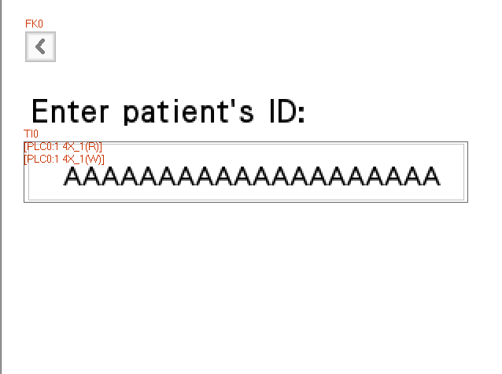
Figure 13: Screen 10: SetPatientID
Components | Item on screen
Text | Enter patient’s ID:
Function key | <
Text Input | The box with multiples A

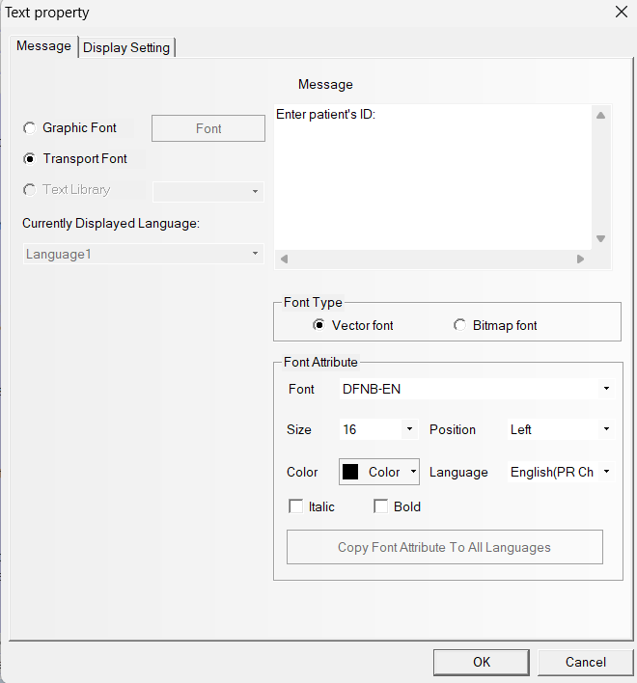
Figure 14: Text – message
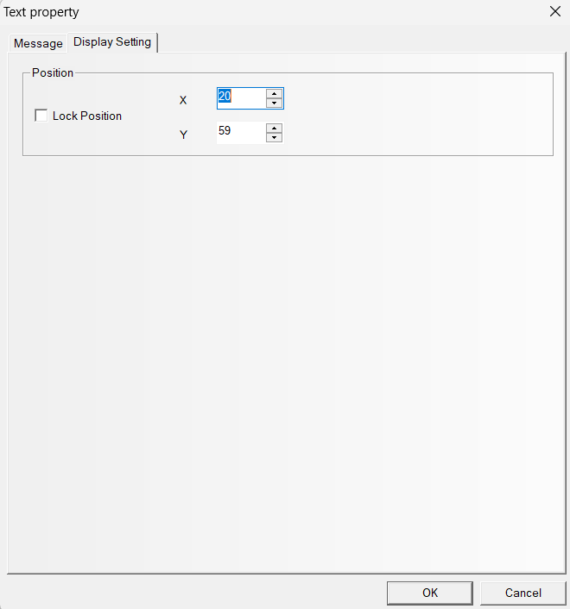
Figure 15: Text - display setting
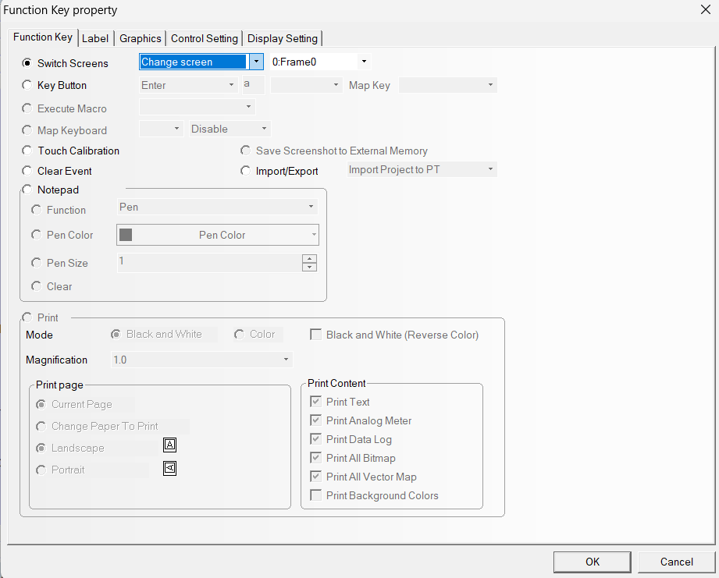
Figure 16: Function key (<)

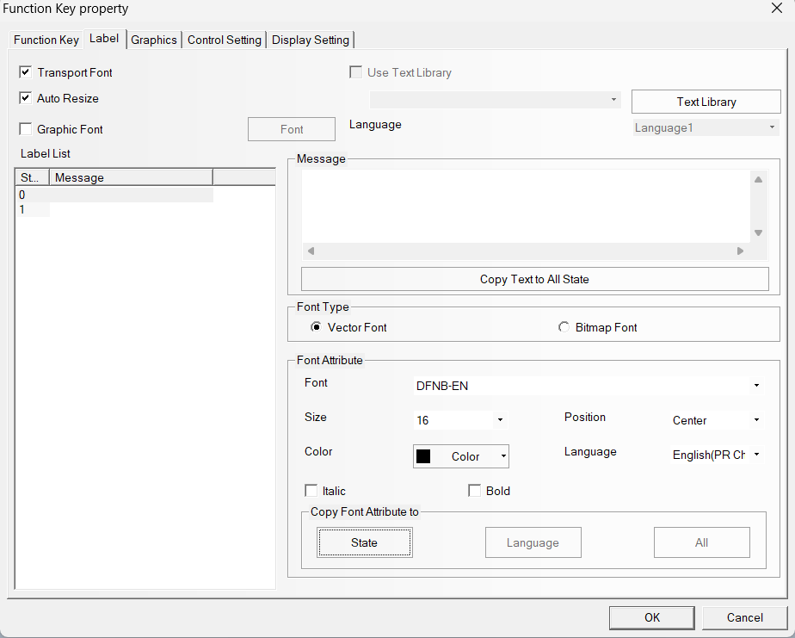
Figure 17: Function key(<) – label (X)
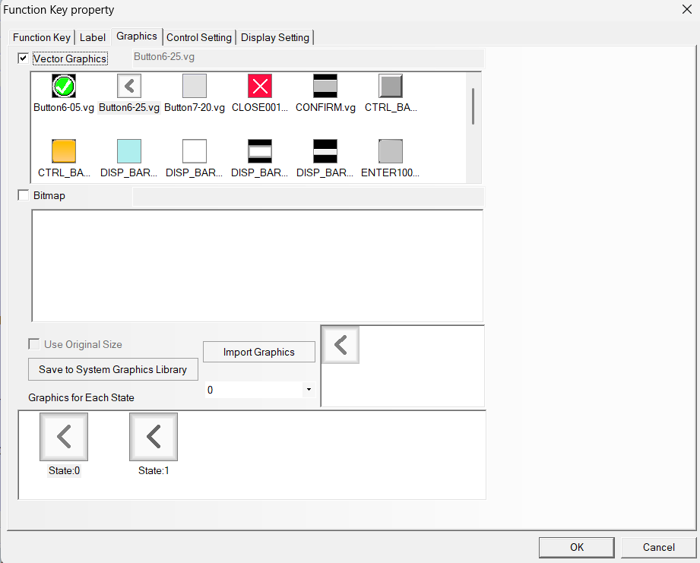
Figure 18: Function key (<) – graphics
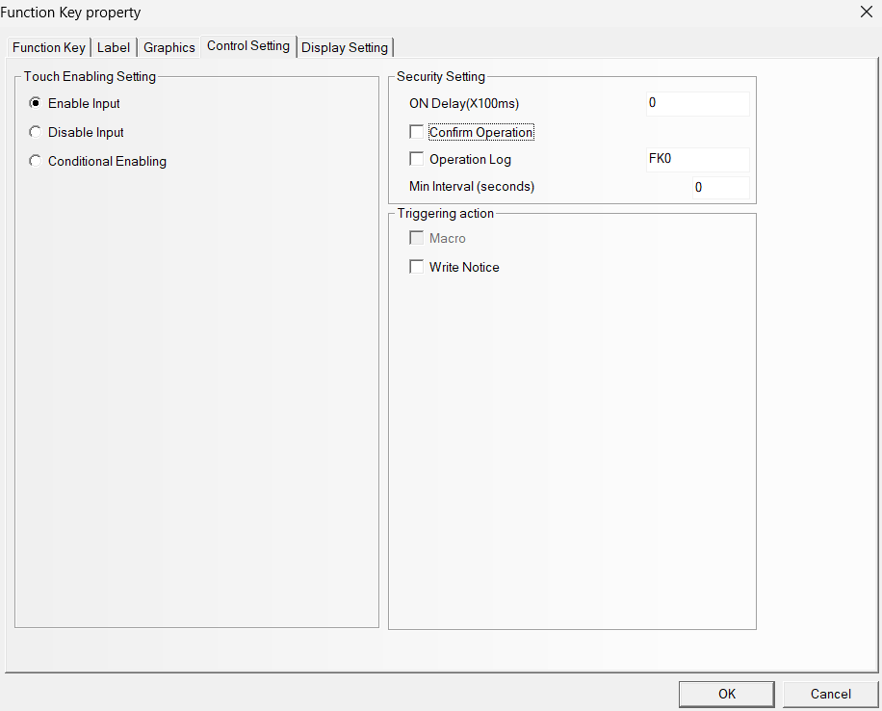
Figure 19: Function key (<) – control setting (X)
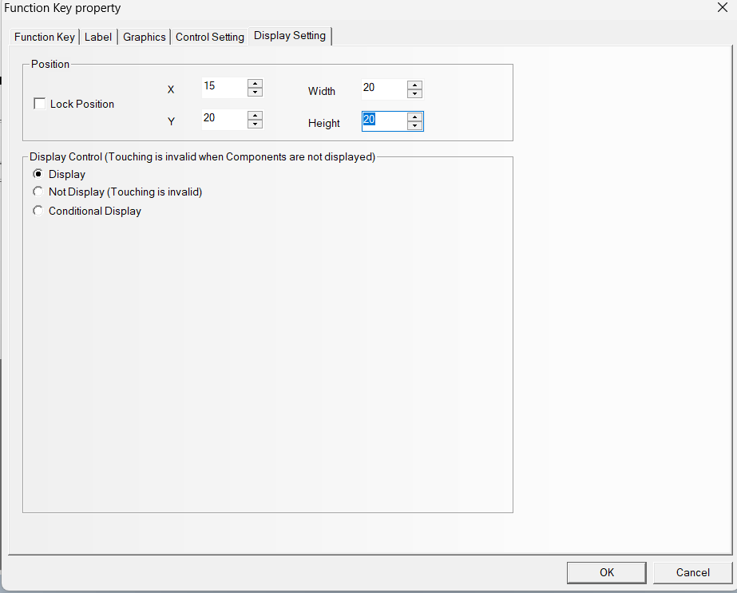
Figure 20: Function key (<) - display setting

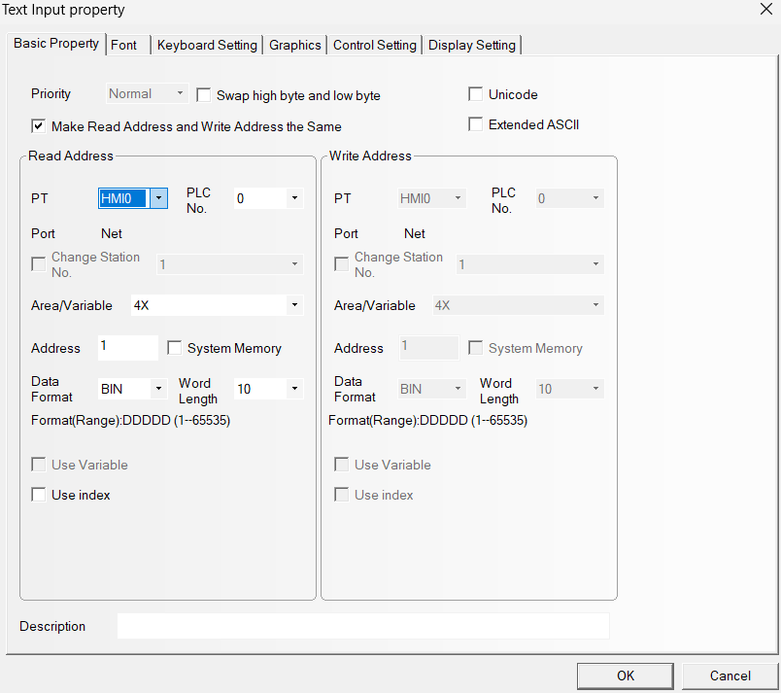
Figure 21: Text Input – basic property
*Word length - 10 = 20 characters

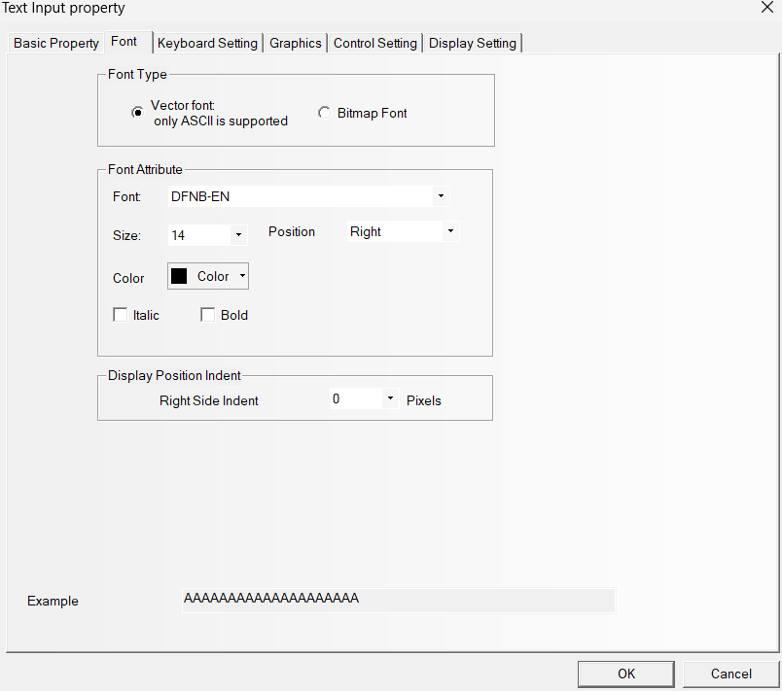
Figure 22: Text Input – font

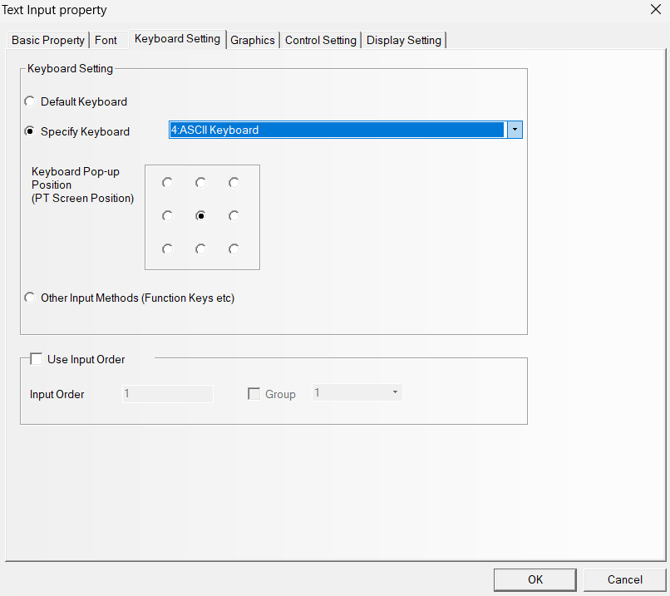
Figure 23: Text input - keyboard setting
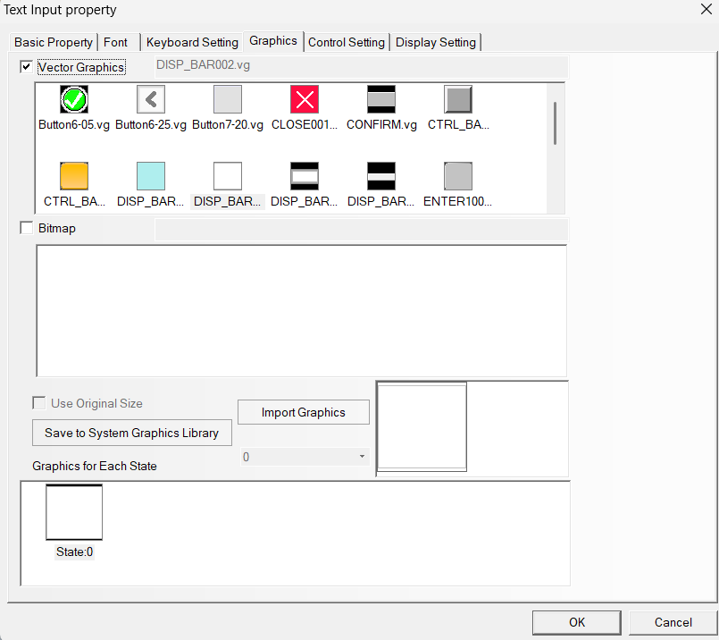
Figure 24: Text Input – graphics

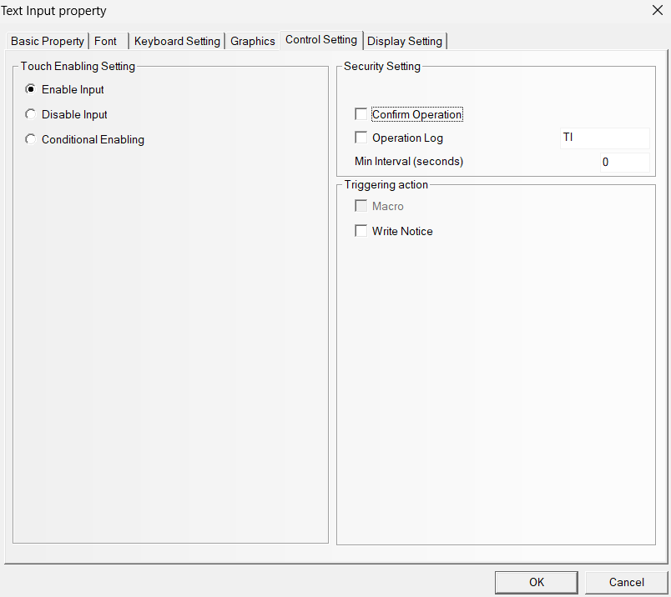
Figure 25: Text Input- control setting (X)
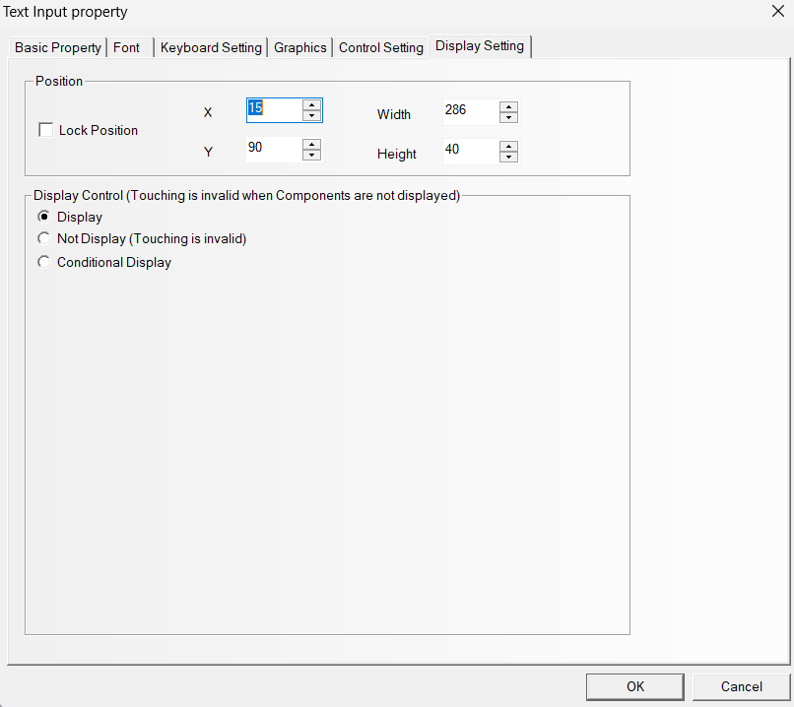
Figure 26: Text input - Display setting

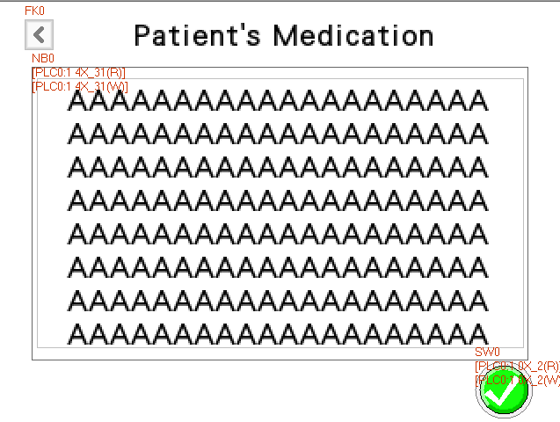
Figure 27: Screen 11- MedicationInfo
Components | Item on screen
Text | Patient’s Medication
Function key | <
Notebook | The box with multiples A
Bit Switch | The tick button

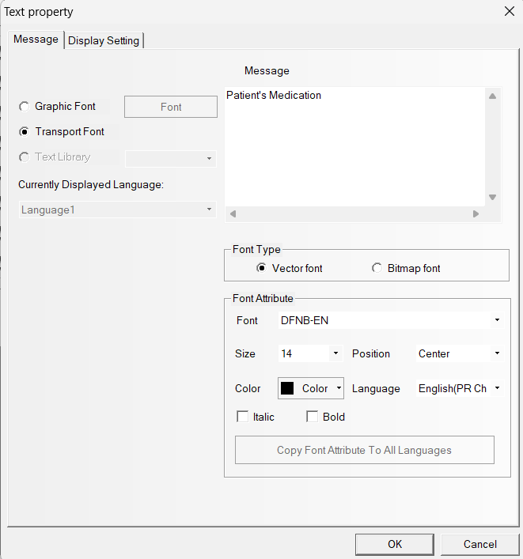
Figure 28: Text – message
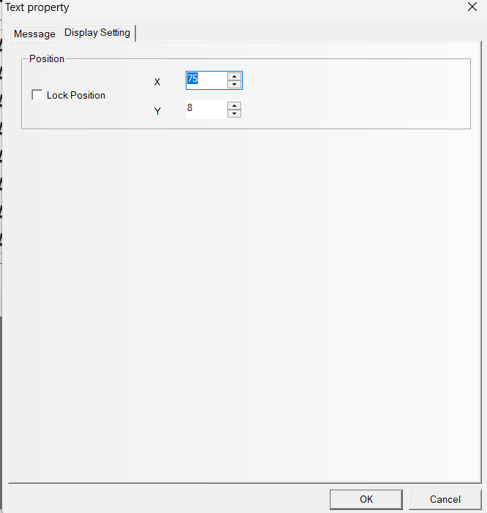
Figure 29: Text - display setting
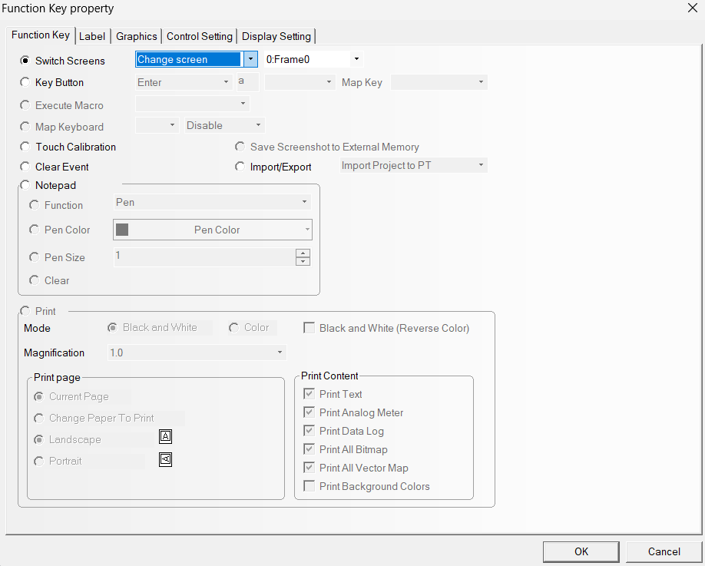
Figure 30: Function key (<)

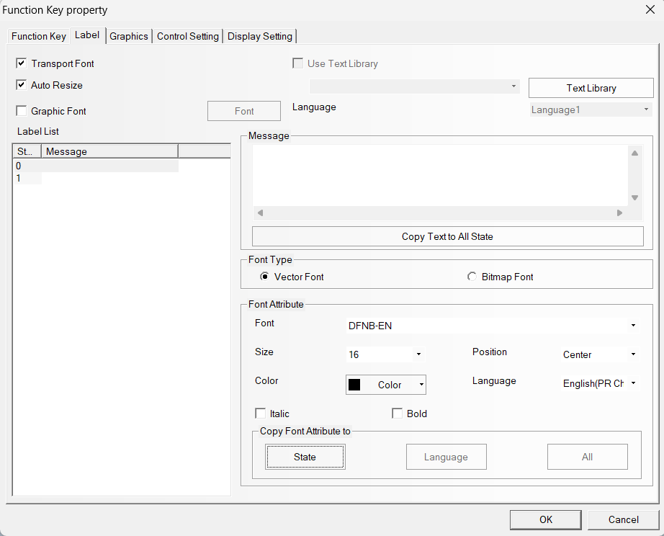
Figure 31: Function key (<) - label (X)
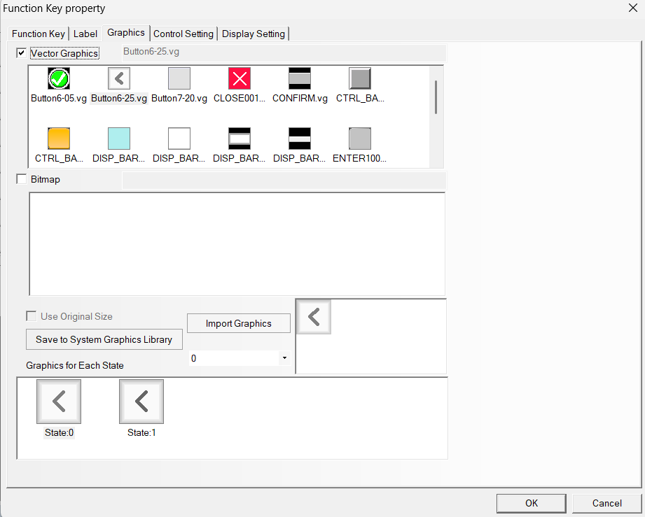
Figure 32: Function key (<) – graphics

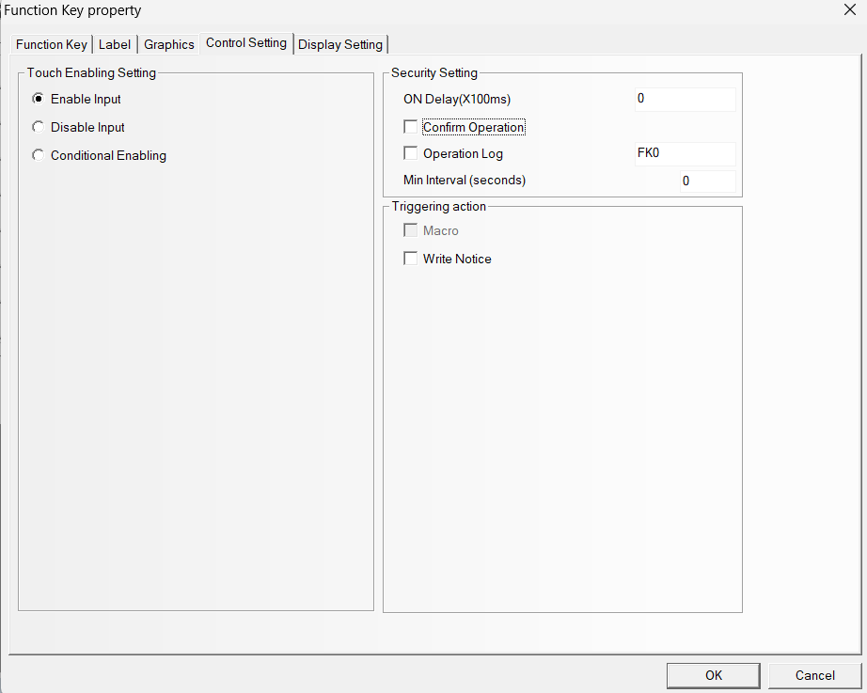
Figure 33: Function key (<) – control setting (X)
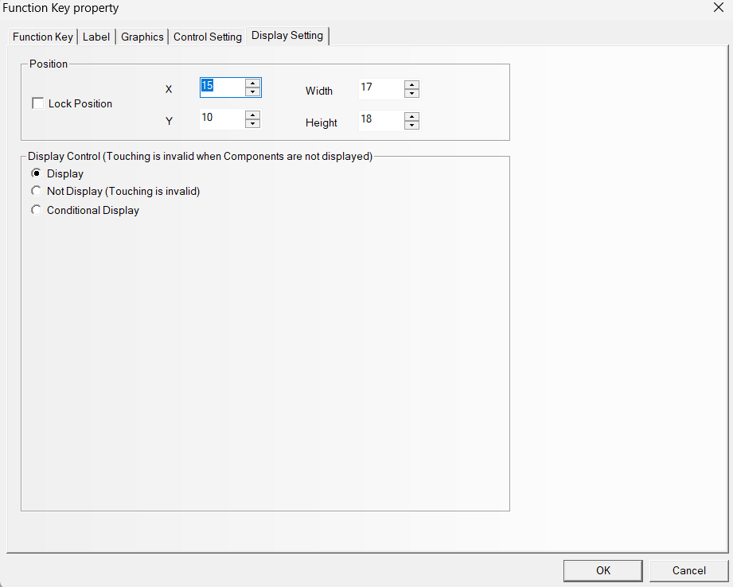
Figure 34: Function key (<) – display setting

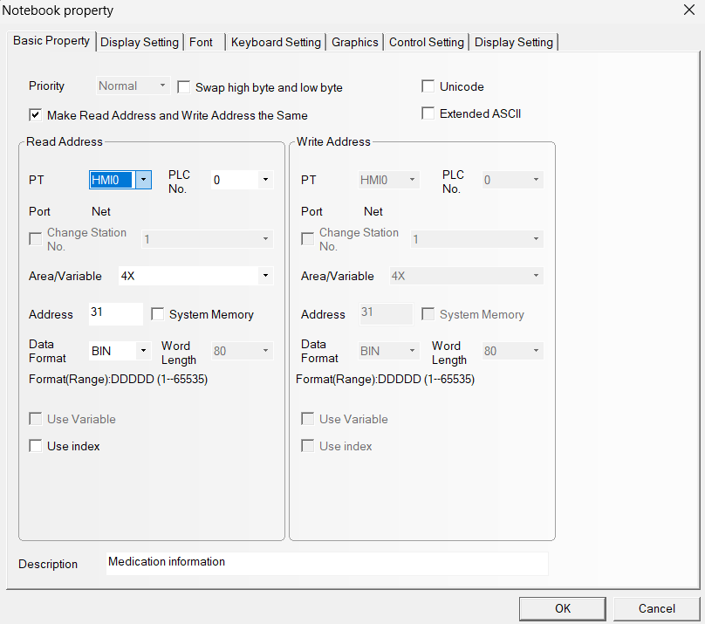
Figure 35: Notebook – basic property
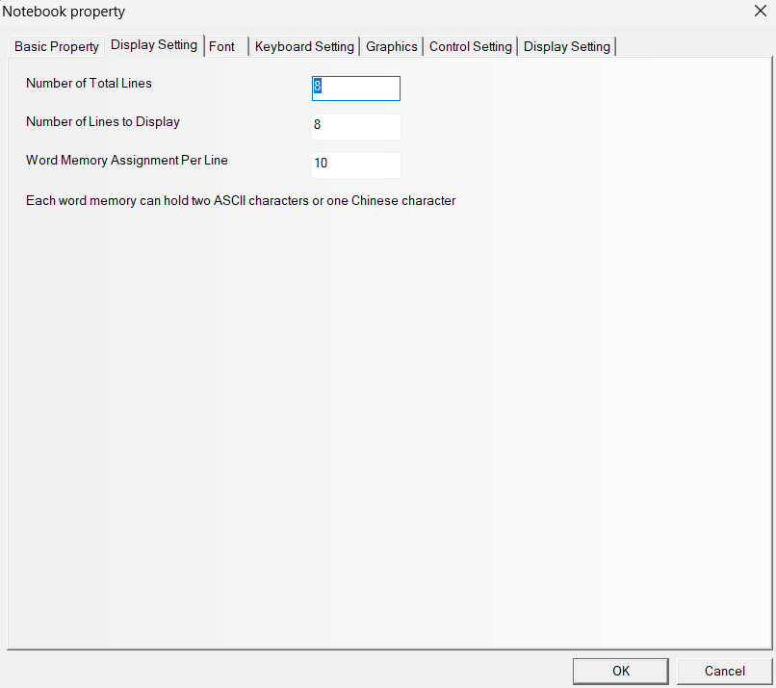
Figure 36: Notebook – display setting
Per line word memory – 10 -> Total 20 characters per line

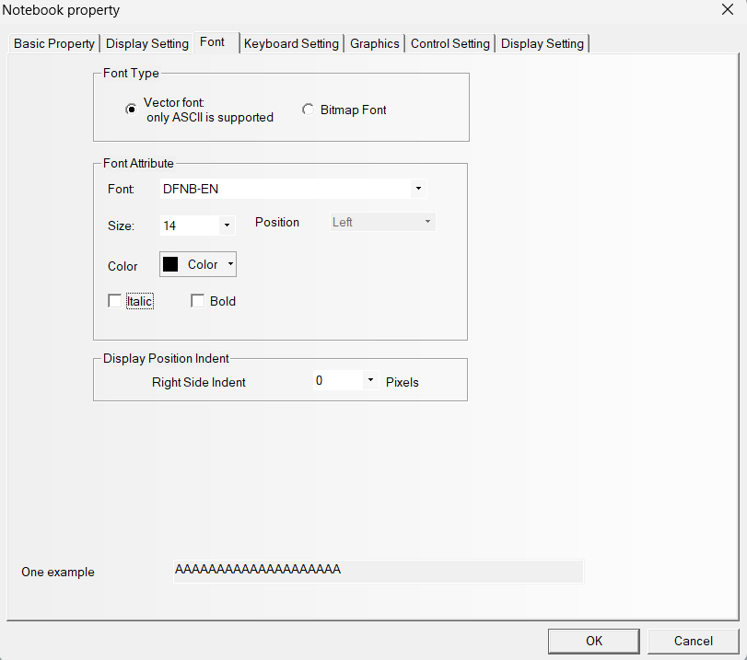
Figure 37:Notebook - font
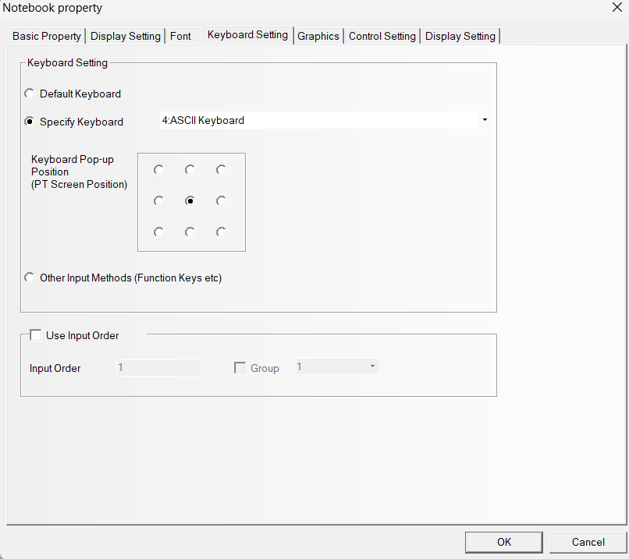
Figure 38: Notebook – keyboard setting (X)
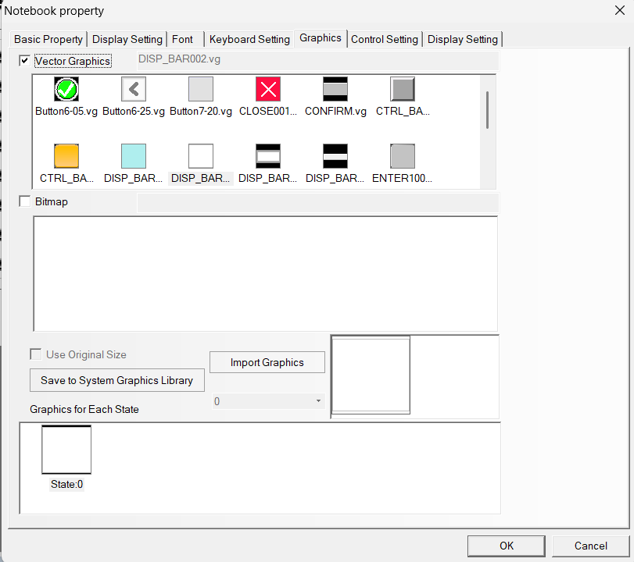
Figure 39: Notebook - graphics
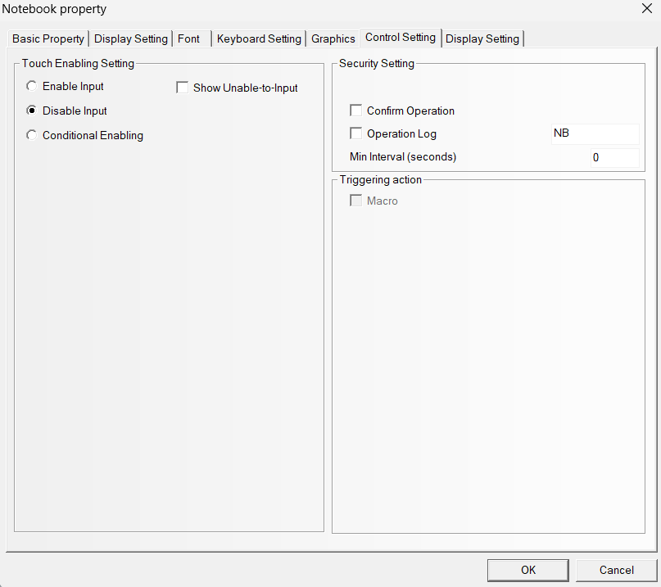
Figure 40: Notebook – control setting ( To configure disable input)

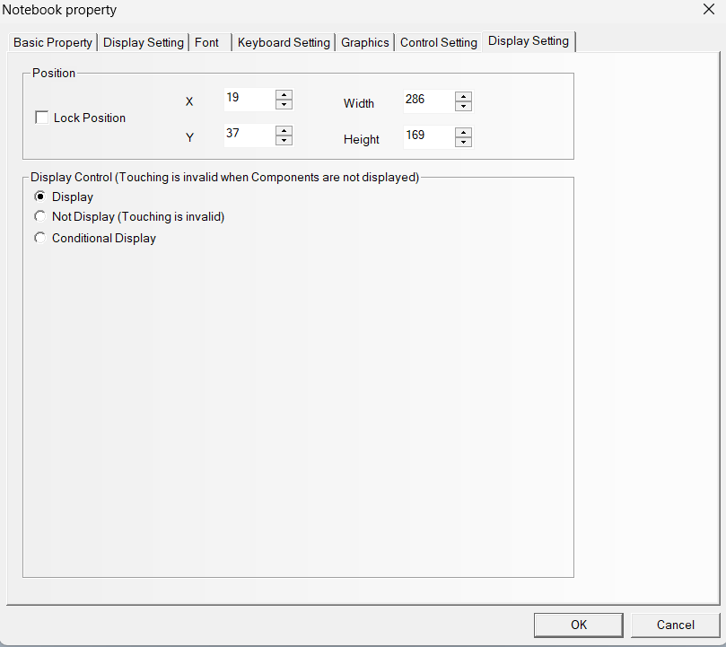
Figure 41: Notebook – display setting

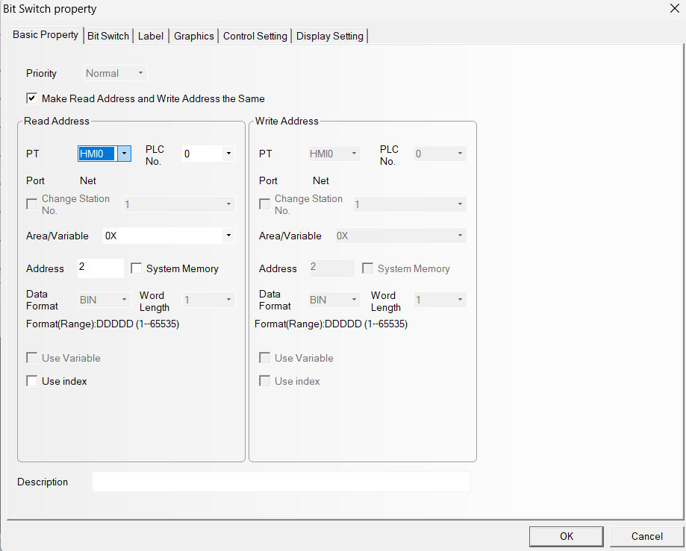
Figure 42: Bit switch - basic property

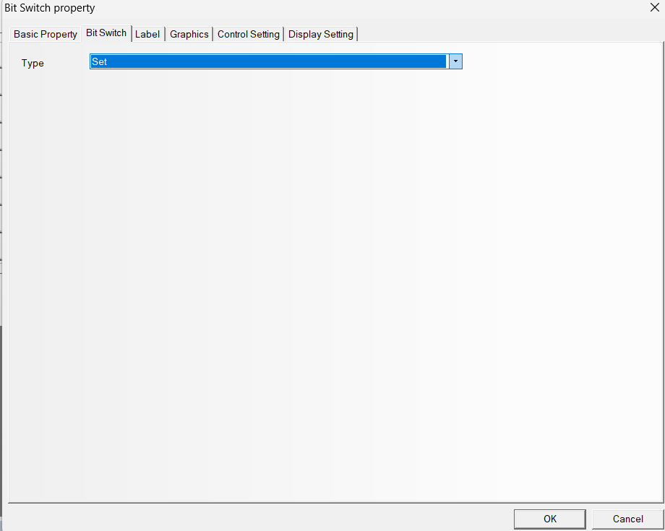
Figure 43: Bit switch - bit switch (X)
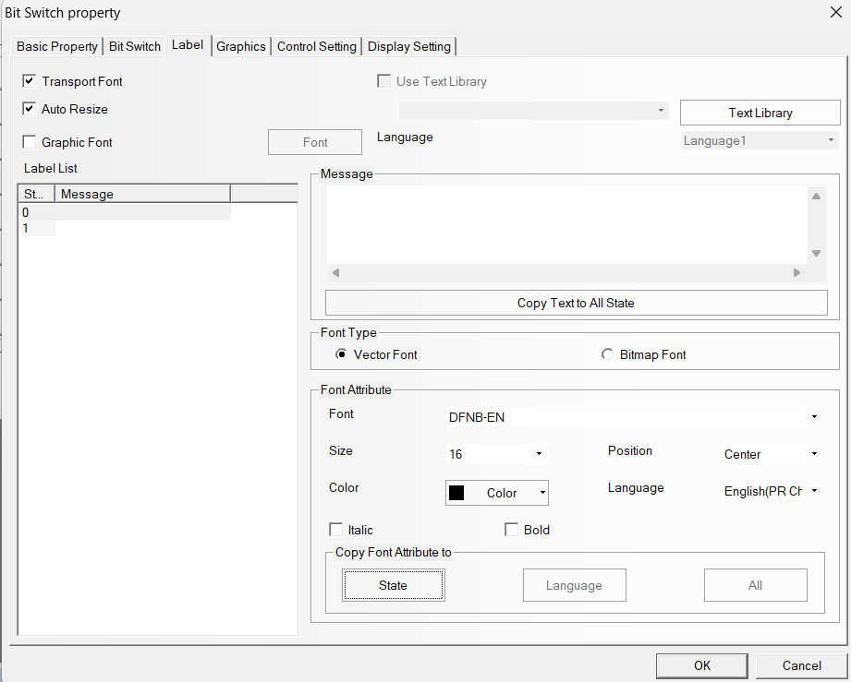
Figure 44: Bit switch - label (X)
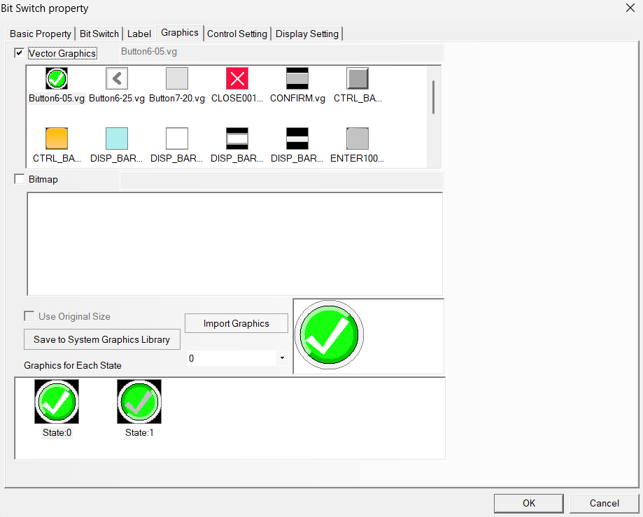
Figure 45: Bit switch – Graphics
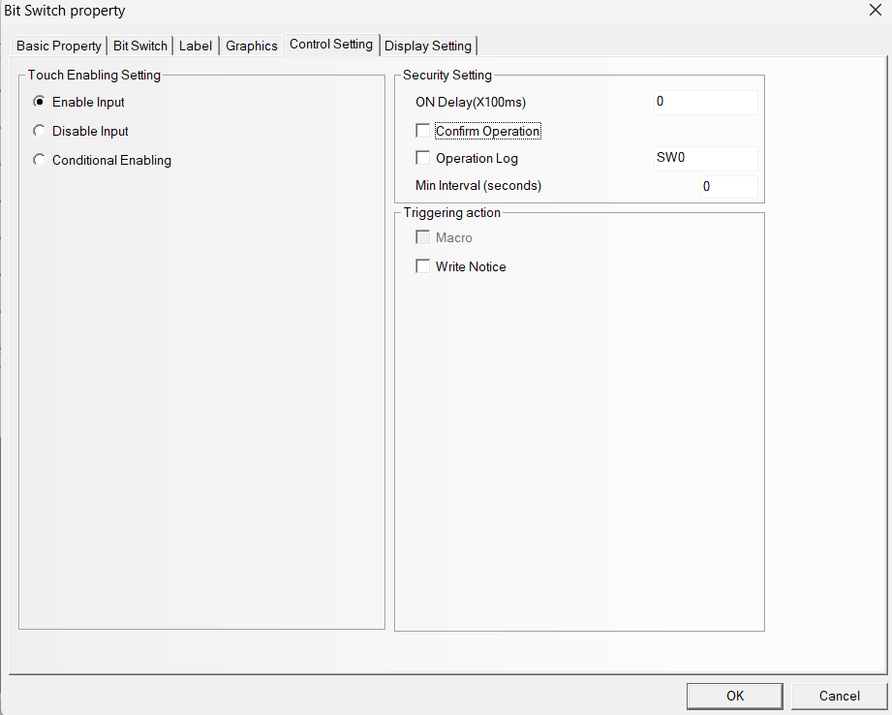
Figure 46: Bit switch - control setting (X)

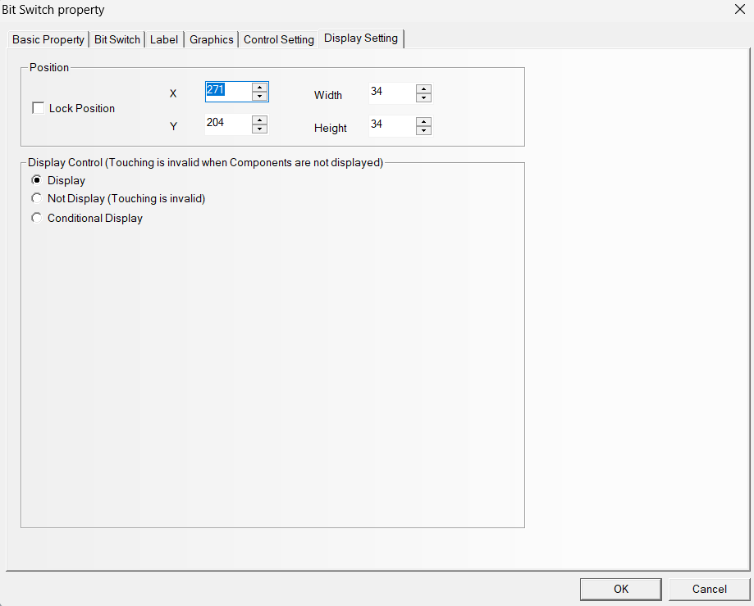
Figure 47: Bit switch - display setting

